Quantifying synchrony and variability in source water quality across a relatively undisturbed nested catchment: contibutions to characterizing a protected water supply area to better understand how forest management strategies influence drinking water treatability and outcomes

Hannah J. McSorley

April 2020

Table of Contents

# Preface

In this book, we will introduce an interesting method.

# Introduction

Here is the introduction to this thesis. I will do several things. It is heavily based on previous seminal work on penguins (Health Canada 2019).

# First Chapter of Research

Here is a research chapter. Look a graph in Figure 1.

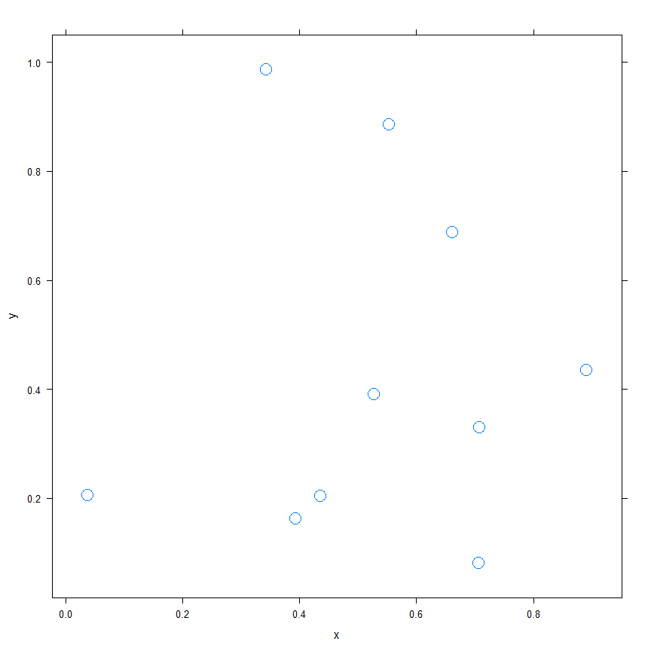

Figure 1: Here is a figure caption.

Also check out the associated data in Table 1.

Table 1: The randomly generated data used for this research.

|  |  |
| --- | --- |
| x | y |
| 0.6611629 | 0.6871721 |
| 0.7077070 | 0.3299362 |
| 0.0367015 | 0.2050604 |
| 0.7063136 | 0.0807440 |
| 0.3926384 | 0.1620240 |
| 0.3426554 | 0.9864994 |
| 0.5525553 | 0.8860584 |
| 0.8913981 | 0.4352978 |
| 0.4359793 | 0.2042507 |
| 0.5273453 | 0.3907263 |

# Conclusions

I did several things and will now discuss why they are good.

Health Canada. 2019. “Guidance on Natural Organic Matter in Drinking Water.” <https://www.canada.ca/content/dam/hc-sc/documents/programs/consultation-organic-matter-drinking-water/NOM20190129-eng.pdf>.